Report 2: System Analysis & Architectural Design Report (Design Phase)

1. System Overview
- Purpose and functionality: "AI Study Hub" is a comprehensive All-in-One Desktop application designed to help users manage study materials, exams, and deadlines efficiently. It features a built-in document viewer and integrates an intelligent AI Assistant (powered by Gemini) to provide contextual lookup, text summarization, and direct interaction with the document's content using RAG (Retrieval-Augmented Generation).
- Intended users: University students, high school students and self-learners.
- Target platform: Windows Desktop Application (built with C# / WPF and MVVM architecture).

2. UML Diagrams
Relevant UML diagrams have been designed to model the system:
- Use Case Diagram: Shows the interactions between the Student actor and the AI Service actor with the system. Key use cases include Manage Subjects, Manage Deadlines, Read Documents, and AI-driven features like Contextual Lookup and Chat.
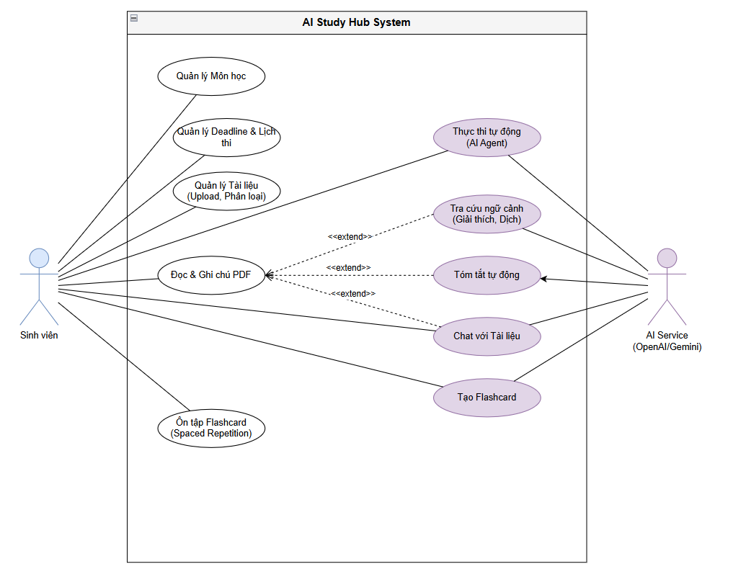
- Class Diagram: Details the core domain models and their relationships, such as User, Subject, Document, Task, Annotation, ChatSession, and Flashcard.
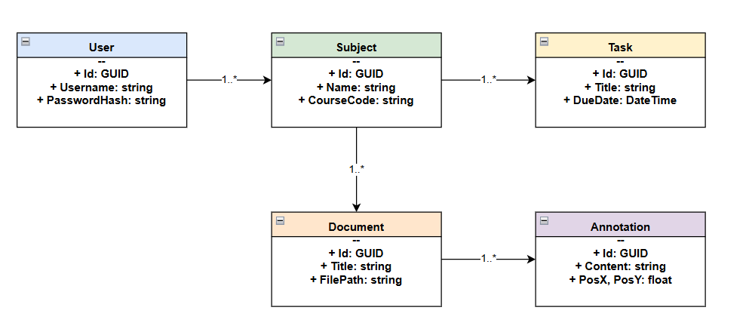
- Sequence Diagram: Illustrates the chronological flow of messages for the "Contextual Lookup (AI Chat)" feature, showing how a user selects text in a document, the system sends it to the AI Service, and displays the response.
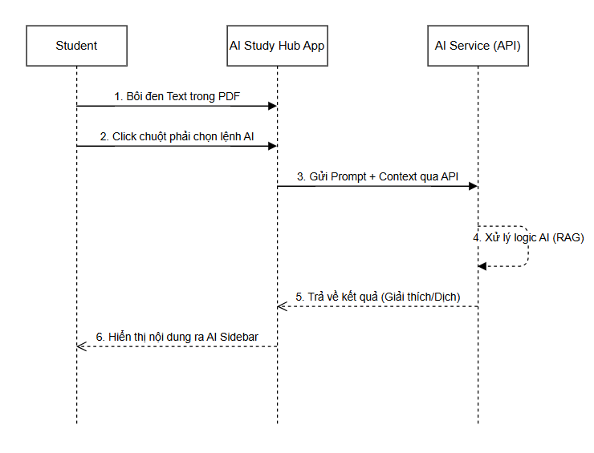
Note: The diagram source codes (Draw.io format) are provided separately.

3. Database Design
- Entity-Relationship Diagram (ERD): The database is designed with high normalization to support future expansions (like Cloud Sync). All primary keys are GUIDs (UNIQUEIDENTIFIER in SQL Server / TEXT in SQLite).
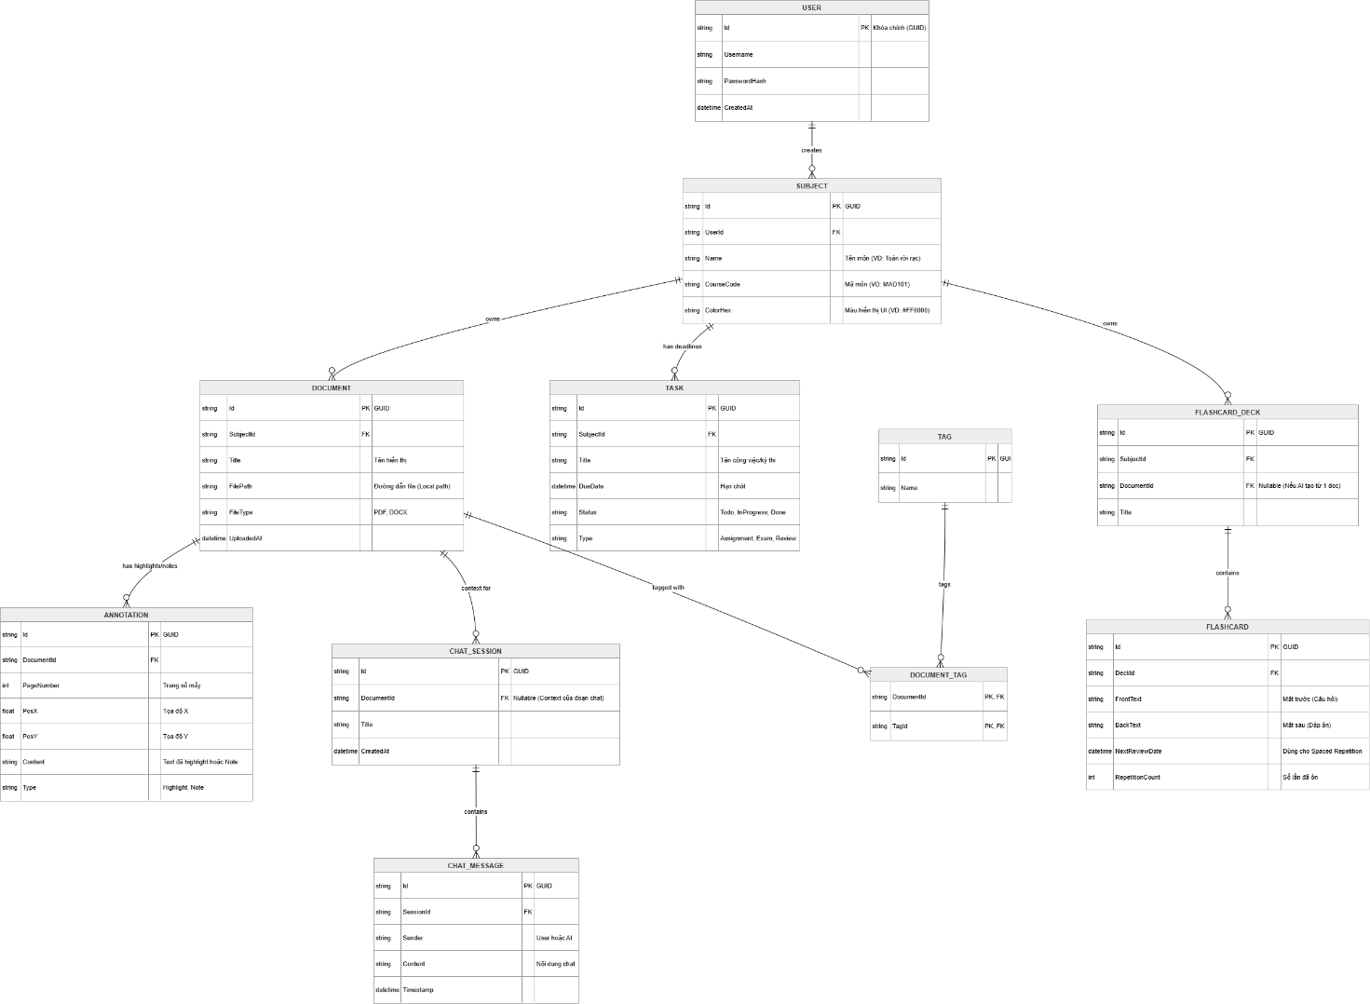
- Database schema and table descriptions:
  - USER: Stores user credentials and profile (preparation for multi-profile/cloud sync).
  - SUBJECT: Workspaces for different courses (Name, CourseCode, ColorHex).
  - DOCUMENT: Stores file paths and metadata for uploaded PDFs/Docs.
  - TASK: Manages deadlines and exams (DueDate, Status, Type).
  - FLASHCARD_DECK & FLASHCARD: Implements Spaced Repetition logic with NextReviewDate and RepetitionCount.
  - CHAT_SESSION & CHAT_MESSAGE: Stores AI chat histories linked to specific documents (RAG context).

4. User Interface (UI) Mockups
- Key screens mockups: Wireframes include the Main Dashboard (Navigation, Subject List), Kanban Task Board, the Split-View Document Reader and AI Chat Sidebar.

- Design rationale and user flow: The UI follows Material Design principles (MaterialDesignInXamlToolkit) for a modern and clean aesthetic. The user flow starts at the Main Dashboard, where they can dive into a specific Subject workspace. From there, they can manage Tasks via a Kanban board or open a Document, which brings up the integrated document viewer alongside the AI Assistant sidebar for seamless study and interaction.

5. CI/CD Planning
- CI/CD tools and pipelines: GitHub Actions will be used as the primary CI/CD tool to automate builds and testing.
- Integration approach:
  - Version Control: Git & GitHub. Developers work on separate feature branches corresponding to their modules.
  - Continuous Integration: Every Pull Request to the main branch triggers a GitHub Actions workflow that restores NuGet packages, builds the .NET WPF solution.
  - Deployment Process: Upon tagging a release, a pipeline will bundle the application and produce a final Windows executable (.exe installer) distributed via GitHub Releases.

6. Team Contributions
The system analysis and architectural design were divided among team members according to their assigned modules:
- Phong (PM & DB Developer): Designed the overall system architecture, ERD, database schemas, and the Subject management module logic.
- Vương (UI/UX Lead): Created UI wireframes, designed the user flow, and set up the architectural framework for the UI (Material Design, resource dictionaries).
- Hòa (Deadline Module): Analyzed and designed the logic for the Task management system, Kanban boards, and countdown timer algorithms.
- Minh (Document Module): Researched and designed the integration flow for the Document Viewer and local file management system.
- Tân (AI Assistant Module): Designed the API integration architecture (HTTP Services for Gemini) and the Sequence Diagram for AI interactions.
- Duy (Annotation & Flashcard Module): Designed note feature and the Spaced Repetition algorithm for Flashcards.

